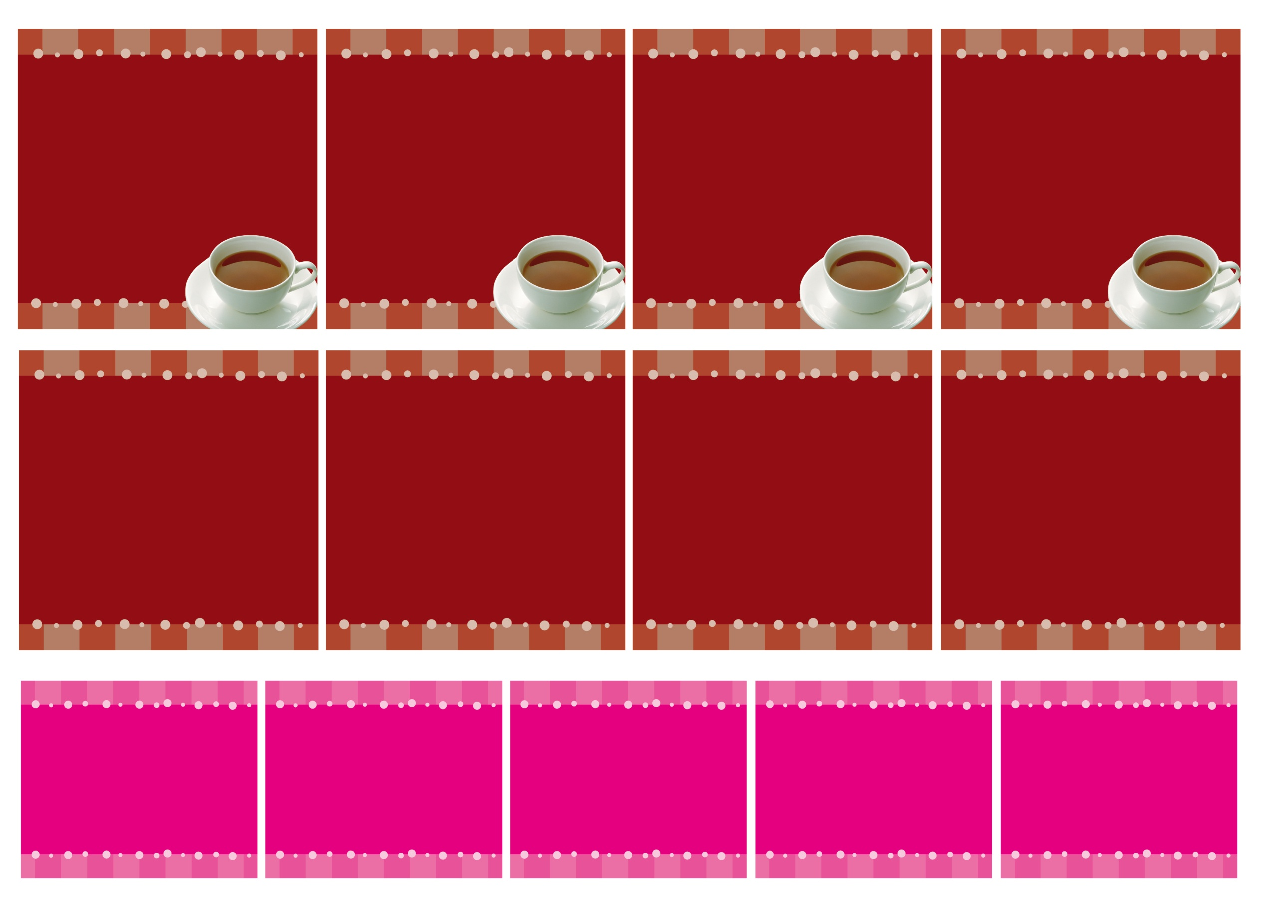

SUGAR

Coffee

Original

Dsign

Plemmium

Blend

Coffee

Original

Dsign

Plemmium

Blend