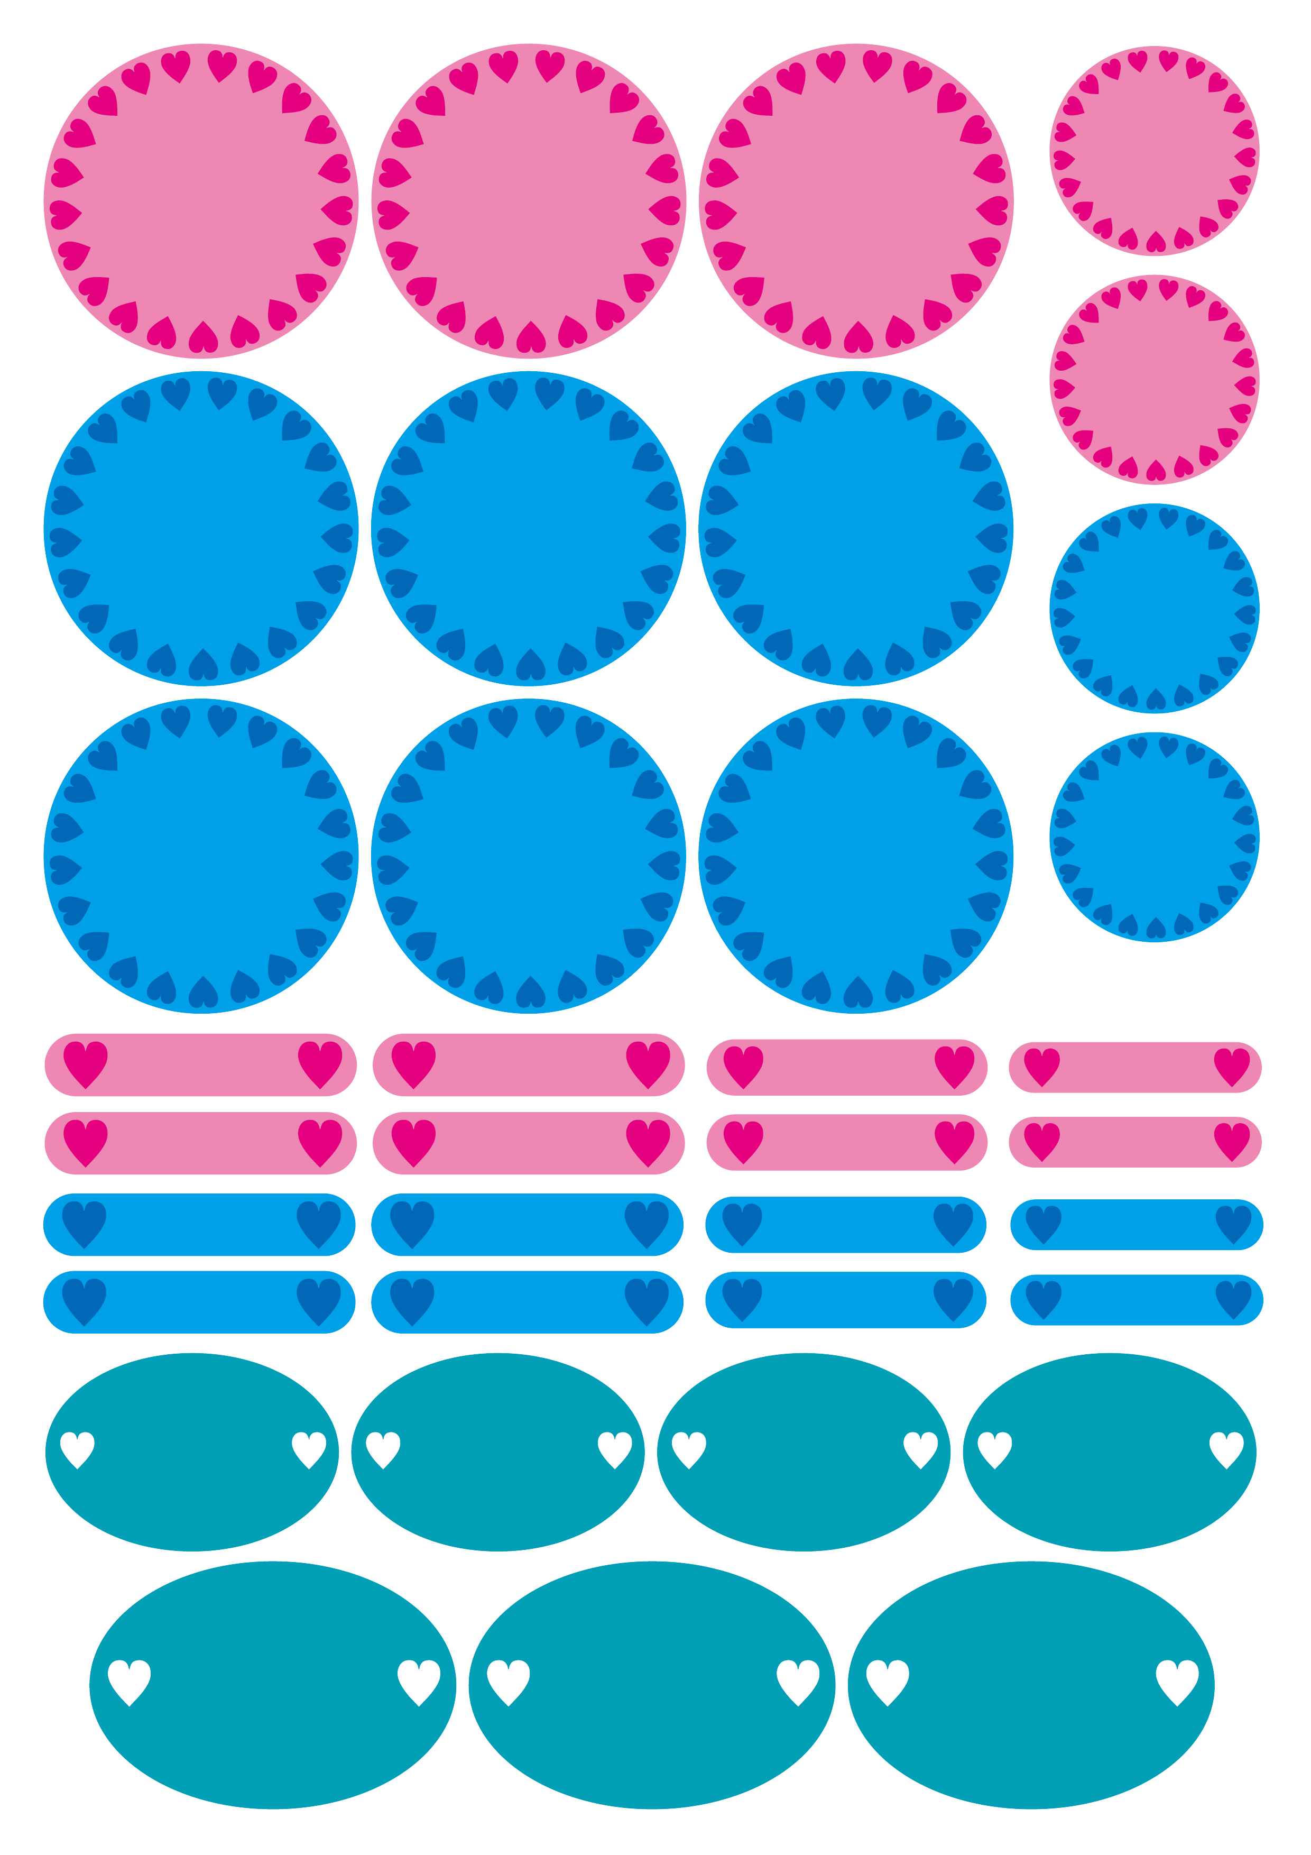

MOUTH

WASH

MOUTH

WASH

Hiroki

Tomoka

Hiroki

Tomoka

Hiroki

Tomoka