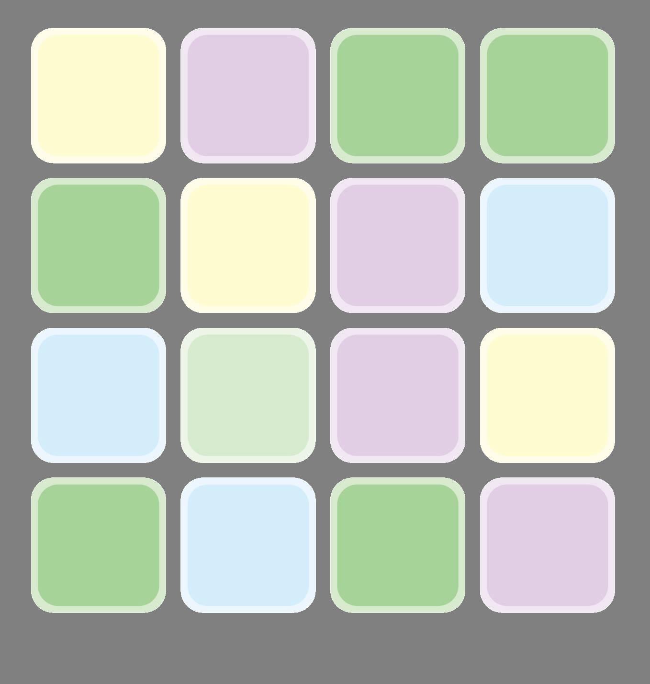

6.000000000000007.000000000000008.000000000000009.00000000000000

1.000000000000002.000000000000003.000000000000004.000000000000005.00000000000000

Mｙ Favorite Songs

