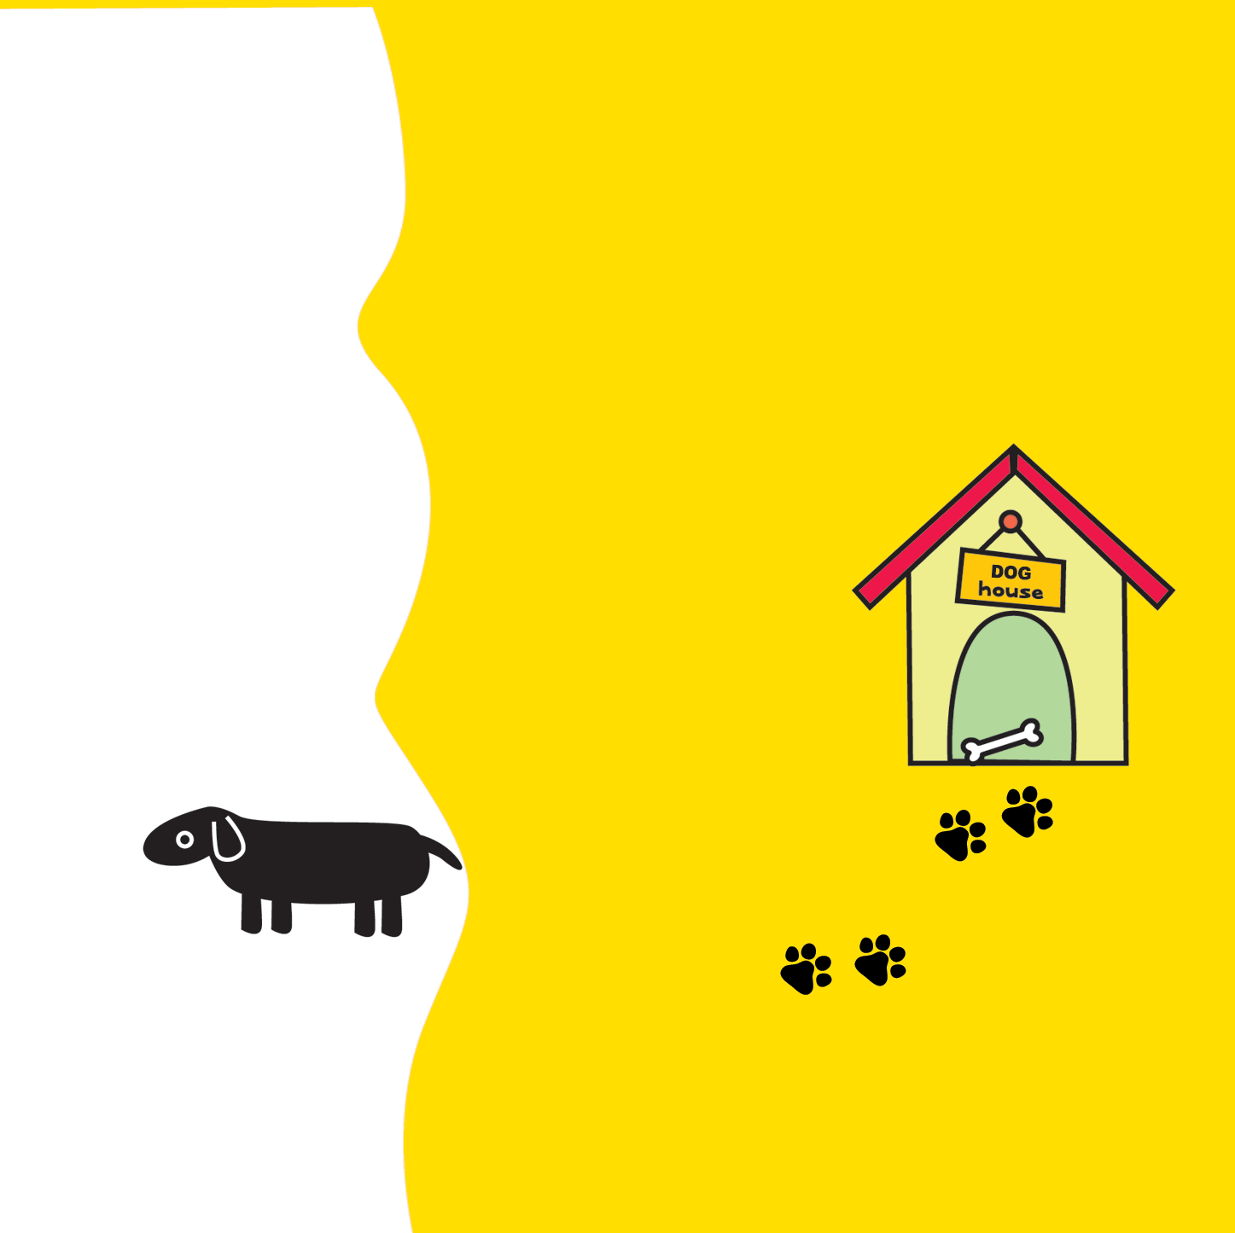

First Drive

**写真をいれてね**

AI 's diary

~ hajimete no tode ~ 001 : in asahi river 002 : in central park 003 : in matsubara sea 004 : in pet shop

